CIE A2 Physics
Review notes (Electric field, capacitance, magnetic field--Notice: motion of charged particles is excluded)

Electric field
- Calculation: force(or acceleration), Field strength, potential, potential difference (), potential energy
  - The key is to identify the scenario (charged plates, sphere, or point charge) and use the correct formula.
  - notice the point charge potential difference has expression: 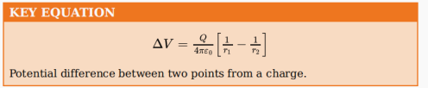
  - Notice the motion of electrons in uniform electric field is parabolic(because the weight of electron is negligible compared with electrostatic force)
  - Questions might be about comparison between electric and gravitational field. Read textbook 22.3 (p627)
  - Relationship between E and V-----the negative of gradient of V is E. See last part for details.
- Graph of potential and field strength
  - 看清楚坐标轴，是V还是E的图，单位是？（特别注意10^n）
  - Identify the scenario--point charge, charged spherical conductor, or charged parallel plates
  - For potential graph
    - Two positive charge---两边高，中间低，整体数值均为正数，因为无穷远为0.
对应题目：topical paper P 306. 6画图；p339 图 注意这个类型题（可以推断出什么结论--charge same or opposite, equal or X is bigger in the amount of charge, radius of sphere）
    - Two negative charge---上面图像关于x轴对称，potential is always negative
    - One negative one positive---一正一负，跨x轴
    - charge大小如何影响shape？——如果equal size，symmetry. if A+ is bigger, its potential is higher
    - point charge还是sphere会怎样影响图像？靠近charge的时候曲线的陡峭程度。理论上point charge附近的E V无穷大（注意是理论上）。
    - 球内部，E为0（why?），V保持不变（horizontal line on the V graph）。
    - E和V 的形态，大致上一样，一个是1/r^2,一个是1/r
  - For electric field graph
    - 两个charge均positive，graph will cross x axis(一个charge的graph类似于1/x^2第一象限，另一个charge的graph类似于1/x^2在第三象限的那支（因为正方向规定了之后，两个charge之间的电场就会是一正一负），根据场的叠加原理，叠加后得到了两个charge整体的E graph，具体见topical paper p296.1 注意存在E=0的点
    - 一正一负会怎么样?
    - 注意：没有绝对的正方向，正方向的选择是arbitrary，这与potential有约定的零点不同。但是必须选定正方向。
Capacitance
- 等效电容计算
  - 串联和并联，需要知道公式如何推导出来，不会的话看教材p644-647
  - 电阻和电容串联（一般不考）topical paper P344，电容在稳定状态下的电阻等效为无穷大。
- 等效电流的经典题型 topical paper P348
Notice: the ammeter has a response time, so impossible to respond immediately to a high frequency (e.g. 50 Hz) Alternating Current. The reading on ammeter is 等效电流. There are several assumptions which are not necessarily valid but in order to solve the A2 problems we will have to accept them:
    - The following assumptions only hold in this particular type of question.
    - Every time the capacitor is charged, it is charged to full.
    - Every time the capacitor discharged, it loses all its stored charge.
    - The equivalent current等效电流 can be used to calculate the charge it stores in the charged plates in total, using Q=I*t where t can be found by 1/ frequency. This means we don’t consider the details of the current changing.(e.g. there is half of time that the discharging circuit is not even on and if the ammeter is real time you will see the reading is zero!)
    - Summary:这种题目不能细想，想得越多越错。

- 球形电容器的计算：电量得失影响V的计算，topical paper P360
- 平行板电容器中的粒子运动（particle motion里面详述）
- discharge曲线与计算
  - Understand time constant τ=RC
  - 能量公式的来源与运用。能量转化为储存在电场里的能量。
  - 较难的是explain its shape
    - pd across capacitor proportional to charge on capacitor
    - pd across resistor equal pd across capacitor
    - current in resistor proportion to pd across it
    - charge proportional to current（重要结论）. so rate of current decreasing decreases as current decrease.(两边求导）

Magnetic field
- 直流导线的磁场，solenoid, one turn of coil
- 电流天平－－－topical paper P438 P466
  - 若干种形态
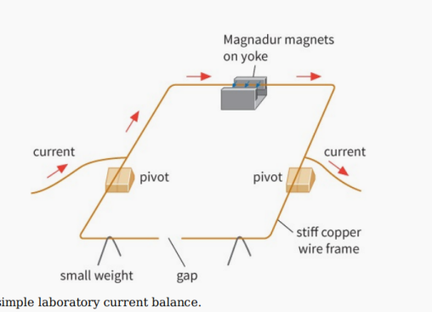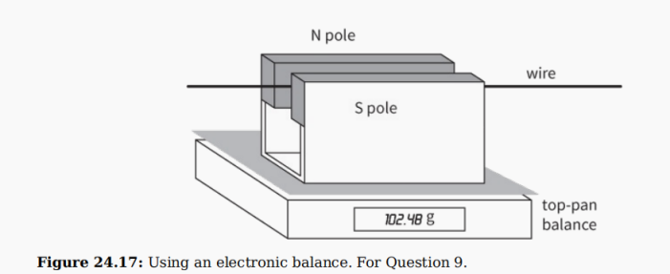

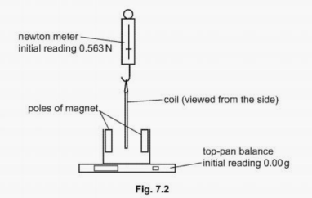

  - 磁场给电流向上的力，电流就给磁场向下的力。
  - Moment calculation = F×d

- 通电线圈在磁场中受力（旋转）recall how to calculate the moment (torque) of force(usually a couple)
(couple’s torque)
- Magnetic force F=BILsinθ，关注电流与磁场的夹角。如果平行，则没有力。
- 简答题详见最后一部分

重要定义，简答题常用内容（需要背诵）
  - Electric field lines & magnetic field lines的常见类型，能准确地画出来吗？
  - Same charge or opposite charge in the graph of E? You can explain in two perspectives
    - near each charge, direction of force OR
    - whether there is zero force point
  - V graph horizontal line means what? Potential inside a conductor is constant, because field strength inside conductor is zero.
  - Coulomb's law, electrostatic force between two point charges is proportional to the product of two electric point charges and inversely proportional to the square of separation
  - electric field line originates from centre, lines are radial.
  - compare gravitational field and electric field:
    - same-both are radial, law have inverse square.
    - Differences-G field: direction is always towards the mass. E field: direction can be towards or away from charge.
  - electric field is force per unit positive charge (注意这个定义！)
  - E=△V/△d，仅仅适用于uniform field between charged parallel plates
electric field at a point = negative of potential gradient at that point.
  - electric potential: work done per unit positive charge in bringing a small test charge from infinity to the point.
  - Electric Potential Energy (point charge)=qV= Qq/(4πε0r)
  - Define capacitance
    - If it is charged parallel plates, C=charge per potential where charge is numerically equal to the charge on one plate.V is the p.d between plates. OR
    - If it is charged spherical conductor, C=charge per potential where charge is numerically equal to the charge on the surface the spherical conductor and V is the potential on the surface of the spherical conductor.
  - Fleming's left hand rule（explain how you find out the direction of ......）
  - magnetic flux density--B-- magnetic field strength---force acting per unit current per unit length on a wire placed at right angles to the magnetic field（注意B=F/IL定义了B）
  - magnetic field is increased by a ferrous core
  - explain the origin of forces of current carrying conductors－－－1. current produced M field around wire . 2. wire sits in the field created by the other, the current is at right angle to the field. so it experiences a force.必须说force, current, field之间的方向。如果问的是attractive or repulsive?就要具体说明根据Fleming’s rule判断的方向。
  - Are the two forces of two current carrying wires equal? Why?
    - newton third law OR
    - force is proportional to the product of the two currents, so the same.
  - magnetic field: a region where a force acts on a current carrying conductor or a magnetic material

